Problem Statement 1

Find out the top 5 most visited destinations.

val delayed_flights = sc.textFile("/home/acadgild/DelayedFlights.csv")

val mapping = delayed_flights.map(x => x.split(",")).map(x => (x(18),1)).filter(x =>

x._1!=null).reduceByKey(_+_).map(x => (x._2,x._1)).sortByKey(false).map(x => (x._2,x._1)).take(5)



Problem Statement 2

Which month has seen the most number of cancellations due to bad weather?

val delayed_flights = sc.textFile("/home/acadgild/DelayedFlights.csv")

val canceled = delayed_flights.map(x => x.split(",")).filter(x => ((x(22).equals("1"))&&

(x(23).equals("B")))).map(x => (x(2),1)).reduceByKey(_+_).map(x =>

(x._2,x._1)).sortByKey(false).map(x => (x._2,x._1)).take(1)

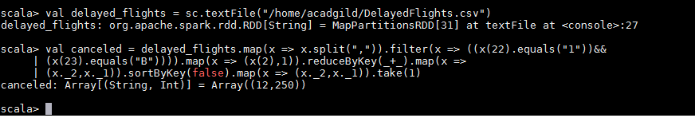

Problem Statement 3

Which route (origin & destination) has seen the maximum diversion?

val delayed_flights = sc.textFile("/home/acadgild/DelayedFlights.csv")

val diversion = delayed_flights.map(x => x.split(",")).filter(x => ((x(24).equals("1")))).map(x =>

((x(17)+","+x(18)),1)).reduceByKey(_+_).map(x => (x._2,x._1)).sortByKey(false).map(x =>

(x._2,x._1)).take(10).foreach(println)

